**K-Means Clustering of People with COVID-19**

**July 2, 2020**

**DoYeong, Jeon  
Software Engineering Laboratory  
Soongsil University**

**Table of Contents**

1. Source Code 3

1.1. Code for Creating Database 3

1.2. Code for Clustering 5

2. Result of Clustering 10

2.1. Loaded Dataset 10

2.2. K-Means 11

# Source Code

## Code for Creating Database

* CreatingDB Class

|  |
| --- |
| class CreatingDB:  *"""  Class for creating random database  """* num_people = 0 *# number of people to create* base_date = None *# the base date of data* def __init__(self, num_people, base_date):  self.num_people = num_people  self.base_date = base_date   def generate_incurred_date(self):  *"""  function to create random incurred date  :return:  incurred_date: string, the day of infection or contact  elapsed_days: int, the difference between base date and incurred date  """* elapsed_days = random.randint(0, 14) *# the valid day period is 0~14  # extracting the incurred day using periods and base date* incurred_date = (self.base_date - timedelta(days=elapsed_days)). \  strftime(**"%Y %m %d"**)  return incurred_date, elapsed_days   def generate_address_list(self):  *"""  function to get one address randomly from the adress list  :return: the randomly generated address list  """* with open(**'./Address_Part.txt'**, **'r'**, encoding=**'utf-8'**) as add_file:  *# add_file = add_file.encoding* address_list = add_file.readlines()   random_address_list = [] *# list to store addresses   # extract addresses as many as the number of recipients* for _ in range(1, self.num_people + 1):  random_address_list.append(random.choice(address_list))   return random_address_list   def generate_csv_data(self):  *"""  function to create .csv file with randomly generated records  :return: None  """* num_healthy = round(self.num_people / 3) *# 1/3 is healthy* num_contacted = round(self.num_people / 3) *# 1/3 is contacted  # 1/3 is confirmed* num_confirmed = self.num_people - num_healthy - num_contacted   id_list = list(range(1, self.num_people + 1)) *# ID as many as people* random.shuffle(id_list) *# shuffle list   # age records as many as people* age_list = list(random.randint(1, 100)  for _ in range(1, self.num_people + 1))  *# address records as many as people* address_list = self.generate_address_list()   severity_list = [] *# severity records as many as people* incurred_date_list = [] *# incurred date list including 'None'(healthy)* status_list = [] *# status(Healthy, Contacted, and Confirmed) list   # Entire people num = healthy + contacted + confirmed  # Repeat as many healthy people* for _ in range(num_healthy):  *# severity_list.append(0)* status_list.append(**'Healthy'**)  incurred_date_list.append(**'None'**)   *# Repeat as many contacted people* for count in range(num_contacted):  date, days = self.generate_incurred_date()  status_list.append(**'Contacted'**)  *# severity_list.append(round(self.compute_severity('contacted', days), 2))* incurred_date_list.append(date)   *# Repeat as many confirmed people* for _ in range(num_confirmed):  date, days = self.generate_incurred_date()  status_list.append(**'Confirmed'**)  *# severity_list.append(round(self.compute_severity('confirmed', days), 2))* incurred_date_list.append(date)   *# converting as pandas DataFrame data type to save .csv* df = pd.DataFrame({  **"ID"**: id_list,  **"Age"**: age_list,  **"Address"**: address_list,  **"Covid Status"**: status_list,  *# "Severity": severity_list,* **"Incurred Date"**: incurred_date_list,  })  df = df.sort_values([**'ID'**], ascending=[True])  df.reset_index(drop=True, inplace=True)   *# saving as .csv file* df.to_csv(**"corona_data.csv"**, mode=**'w'**, encoding=**'utf-8-sig'**) |

## Code for Clustering

* ClusteringPeople Class

|  |
| --- |
| from datetime import datetime, timedelta from dateutil.parser import parse import random import pandas as pd import numpy as np import sklearn from sklearn import cluster from sklearn.metrics import silhouette_score import matplotlib.pyplot as plt from matplotlib import cm   class CreatingDB:  *"""  Class for creating random database  """* num_people = 0 *# number of people to create* base_date = None *# the base date of data* def __init__(self, num_people, base_date):  self.num_people = num_people  self.base_date = base_date   def generate_incurred_date(self):  *"""  function to create random incurred date  :return:  incurred_date: string, the day of infection or contact  elapsed_days: int, the difference between base date and incurred date  """* elapsed_days = random.randint(0, 14) *# the valid day period is 0~14  # extracting the incurred day using periods and base date* incurred_date = (self.base_date - timedelta(days=elapsed_days)). \  strftime(**"%Y %m %d"**)  return incurred_date, elapsed_days   def generate_address_list(self):  *"""  function to get one address randomly from the adress list  :return: the randomly generated address list  """* with open(**'./Address_Part.txt'**, **'r'**, encoding=**'utf-8'**) as add_file:  *# add_file = add_file.encoding* address_list = add_file.readlines()   random_address_list = [] *# list to store addresses   # extract addresses as many as the number of recipients* for _ in range(1, self.num_people + 1):  random_address_list.append(random.choice(address_list))   return random_address_list   def generate_csv_data(self):  *"""  function to create .csv file with randomly generated records  :return: None  """* num_healthy = round(self.num_people / 3) *# 1/3 is healthy* num_contacted = round(self.num_people / 3) *# 1/3 is contacted  # 1/3 is confirmed* num_confirmed = self.num_people - num_healthy - num_contacted   id_list = list(range(1, self.num_people + 1)) *# ID as many as people* random.shuffle(id_list) *# shuffle list   # age records as many as people* age_list = list(random.randint(1, 100)  for _ in range(1, self.num_people + 1))  *# address records as many as people* address_list = self.generate_address_list()   severity_list = [] *# severity records as many as people* incurred_date_list = [] *# incurred date list including 'None'(healthy)* status_list = [] *# status(Healthy, Contacted, and Confirmed) list   # Entire people num = healthy + contacted + confirmed  # Repeat as many healthy people* for _ in range(num_healthy):  *# severity_list.append(0)* status_list.append(**'Healthy'**)  incurred_date_list.append(**'None'**)   *# Repeat as many contacted people* for count in range(num_contacted):  date, days = self.generate_incurred_date()  status_list.append(**'Contacted'**)  *# severity_list.append(round(self.compute_severity('contacted', days), 2))* incurred_date_list.append(date)   *# Repeat as many confirmed people* for _ in range(num_confirmed):  date, days = self.generate_incurred_date()  status_list.append(**'Confirmed'**)  *# severity_list.append(round(self.compute_severity('confirmed', days), 2))* incurred_date_list.append(date)   *# converting as pandas DataFrame data type to save .csv* df = pd.DataFrame({  **"ID"**: id_list,  **"Age"**: age_list,  **"Address"**: address_list,  **"Covid Status"**: status_list,  *# "Severity": severity_list,* **"Incurred Date"**: incurred_date_list,  })  df = df.sort_values([**'ID'**], ascending=[True])  df.reset_index(drop=True, inplace=True)   *# saving as .csv file* df.to_csv(**"corona_data.csv"**, mode=**'w'**, encoding=**'utf-8-sig'**)   class ClusteringPeople:  df_corona = None  cluster_result_dic = {}   def __init__(self, file_path):  self.load_data(file_path)   def load_data(self, file_path):  *"""  method to load .csv file  :param file_path: string, the path of file  :return:  """* self.df_corona = pd.read_csv(file_path)   def display_load_data(self):  print(**f"**{**'ID'**:**<4**}{**'Age'**:**<4**}{**'Covid Status'**:**<13**}{**'Severity'**:**<9**}{**'Address'**:**<10**}**"**)  for i in range(len(self.df_corona)):  print(**f"**{self.df_corona[**'ID'**][i]:**<4**}**"  f"**{self.df_corona[**'Age'**][i]:**<4**}**"  f"**{self.df_corona[**'Covid Status'**][i]:**<13**}**"  f"**{round(self.df_corona[**'Severity'**][i], 3):**<9**}**"  f"**{self.df_corona[**'Address'**][i].split()[0]:**<10**}**"** )  print() *# float 1 line* def preprocess(self):  *"""  method to preprocess the data for distance function  :return: None  """* col_num = len(self.df_corona) *# the number of rows from loaded data* today = datetime.now().date() *# date of today, YEAR-MONTH-DAY   # selecting specific column to compute 'severity'* incur_date_col = self.df_corona[**'Incurred Date'**]  status = self.df_corona[**'Covid Status'**]   severity_list = [] *# list for storing severity result* for i in range(col_num):  severity = 0 *# default is healthy, 0.* if status[i] == **'Contacted'**: *# contacted person?  # formula for contacted person:  # x = 1 - ((today's date) - (infected date)) * 0.05)* elapsed_days = (today - parse(incur_date_col[i]).date()).days  severity = 1 - (elapsed_days * 0.05)  elif status[i] == **'Confirmed'**: *# confirmed person?  # formula for confirmed person:  # x = (1 - ((today's date) - (infected date)) * 0.05)) / 2* elapsed_days = (today - parse(incur_date_col[i]).date()).days  severity = (1 - (elapsed_days * 0.05)) * 0.5   severity_list.append(severity) *# add the value to the list* self.df_corona[**"Severity"**] = severity_list   def cluster(self):  sse_list = [] *# list for storing SSE(Sum of squares errors)* silhouette_score_list = [] *# list for storing silhouette scores* for i in range(2, 10): *# number of clusters 2 to 9  # load the k-means model* km = cluster.KMeans(  n_clusters=i, *# the number of cluster* init=**'k-means++'**, *# how to initial cluster centers* max_iter=300, *# maximum number of iterations* algorithm=**'auto'** *# three choices: auto, full, and elkan.* )   *# changing the shape of data* severity_list = self.df_corona[**"Severity"**].values.tolist()  severity_list = np.array(severity_list)   *# cluster* cluster_predicted_list = km.fit_predict(severity_list.reshape(-1, 1))   *# storing SSE value to get the optimal number of cluster* sse_list.append(km.inertia_)   *# storing silhouette score to get optimal number of cluster* silhouette_score_list.append(silhouette_score(severity_list.reshape(-1, 1), cluster_predicted_list))   cluster_list = [j for j in range(i)] *# cluster list  # display the reuslt of cluster* self.print_result_of_cluster(cluster_list, cluster_predicted_list)   *# store the prediction result* self.cluster_result_dic[i] = cluster_predicted_list   def draw_elbow_method(self, sse_list):  *"""  method to draw elbow graph using SSE(Sum of Squares Error)  :param sse_list: list of SSE  :return: None  """* plt.plot(range(2, 10), sse_list, marker=**'o'**)  plt.xlabel(**"The Number of Cluster"**)  plt.ylabel(**"SSE"**)  plt.show()   def print_result_of_cluster(self, cluster_list, cluster_predicted_list):  *"""  form  Cluster 1:  Number of people: n  Severity Values: [...]  Average of severities: n  Cluster 2:  ...   :return:  """* severity_list = self.df_corona[**"Severity"**].values.tolist()  id_list = self.df_corona[**"ID"**].values.tolist()   cluster_predicted_list = cluster_predicted_list.tolist()  print(**f"The number of Cluster:** {len(cluster_list)}**"**)  for cluster_idx in cluster_list:  num_people = cluster_predicted_list.count(cluster_idx)  id_severity_tuple_list = []  sum_of_severities = 0  for person_idx in range(len(cluster_predicted_list)):  if cluster_idx == cluster_predicted_list[person_idx]:  sum_of_severities += severity_list[person_idx]  id_severity_tuple_list.append((person_idx+1, round(severity_list[person_idx], 2)))  print(**f"**\t**Cluster** {cluster_idx}**:"**)  print(**f"**\t\t**Number of People:** {num_people}**"**)  print(**f"**\t\t**People list with Severity Values:"**)  print(**f"**\t\t\t{**'ID'**:**<4**}{**'Severity Value'**}**"**)  for person_in_cluster in id_severity_tuple_list:  if id_severity_tuple_list.index(person_in_cluster) % 2 == 0:  print(**f"**\t\t\t{person_in_cluster[0]:**<4**}{person_in_cluster[1]}**"**)   print(**f"**\t\t**Average of severities:** {round(sum_of_severities / len(id_severity_tuple_list), 2)}**"**)  print() *# float 1 line* def draw_silhouette(self):  *"""  method to draw graph using silhouette scores  :return: None  """* pass   def draw_graph(self):  *"""  method to draw clustering result  :return: None  """* pass   if __name__ == **'__main__'**:  *# CODE FOR CREATING DATABASE  # require the number of people and base date  # num_people = int(input("Enter the number of people: "))  # date_input = input("Enter the base date(Year-Month-Day): ")  # if date_input == '':  # print("The base date is set as today.")  # date = datetime.now().date()  # else:  # date = parse(date_input).date()  #  # cdb = CreatingDB(num_people, date) # creating instance  # cdb.generate_csv_data() # creating .csv file   # CODE FOR CLUSTERING* file_path = **'./corona_data.csv'** cp = ClusteringPeople(file_path)  cp.preprocess()  cp.display_load_data()  cp.cluster()  *# cp.draw_graph()* |

* main

|  |
| --- |
| if __name__ == **'__main__'**:  *# CODE FOR CLUSTERING* file_path = **'./corona_data.csv'** cp = ClusteringPeople(file_path)  cp.preprocess()  cp.draw_graph()  cp.cluster() |

# Result of Clustering

## Loaded Dataset

* Top 25 lines

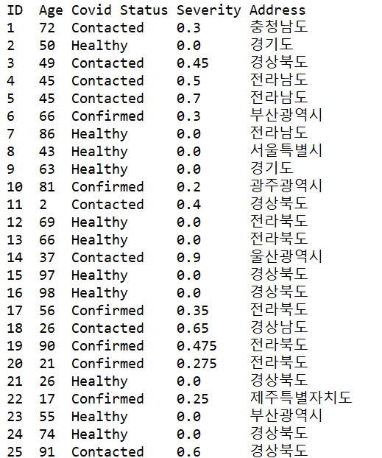

* Last 25 lines

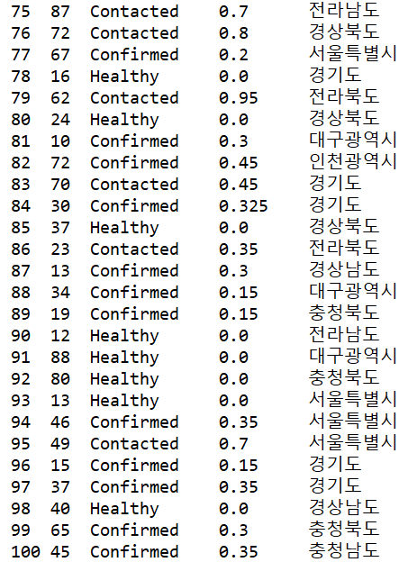

## K-Means

* The number of Cluster: 2
* Cluster 0

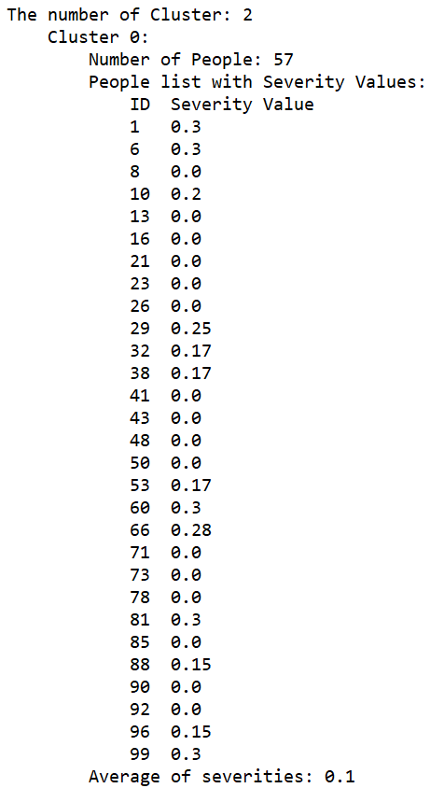

* Cluster 1

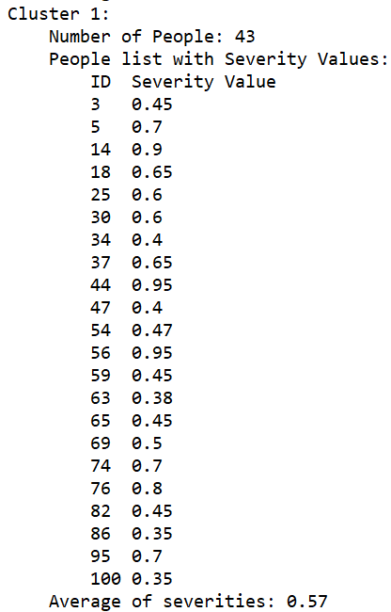

* The number of Cluster: 3
* Cluster 0, 1

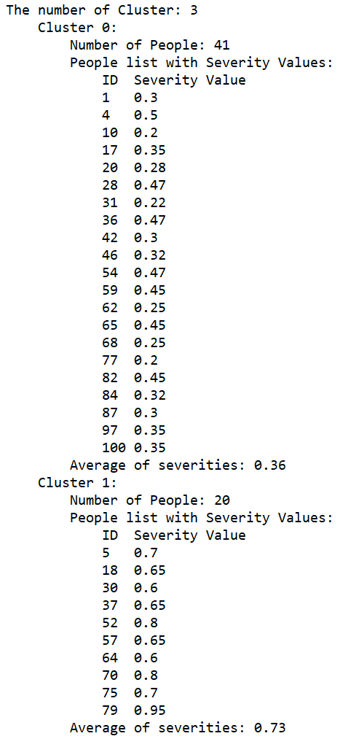

* Cluster 2

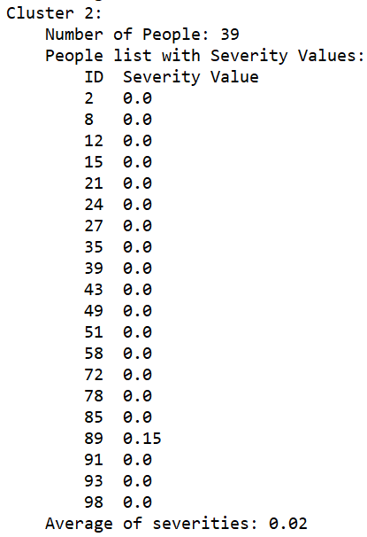

* The number of Cluster: 4
* Cluster 0

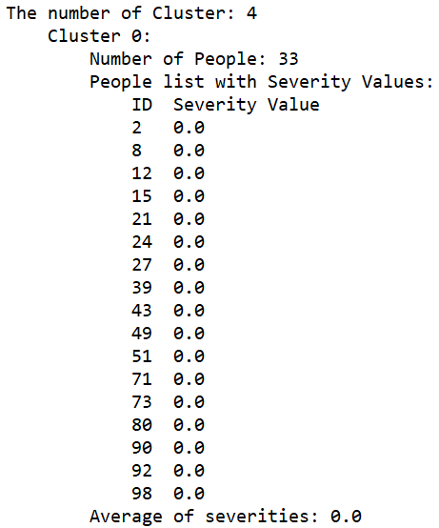

* Cluster 1, 2, 3

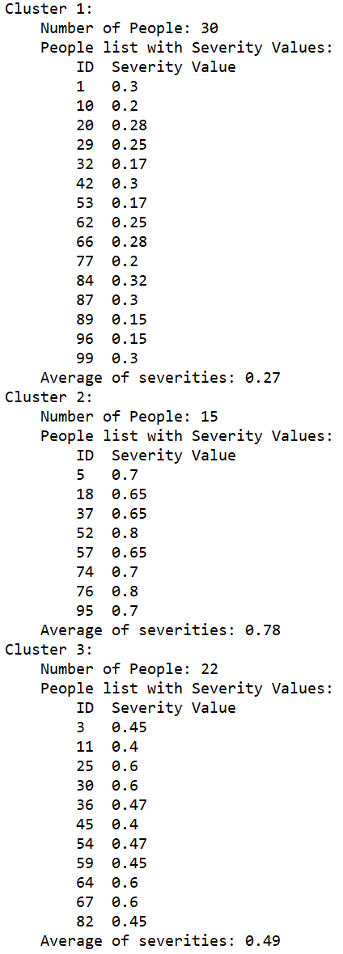

* The number of Cluster: 5
* Cluster 0, 1

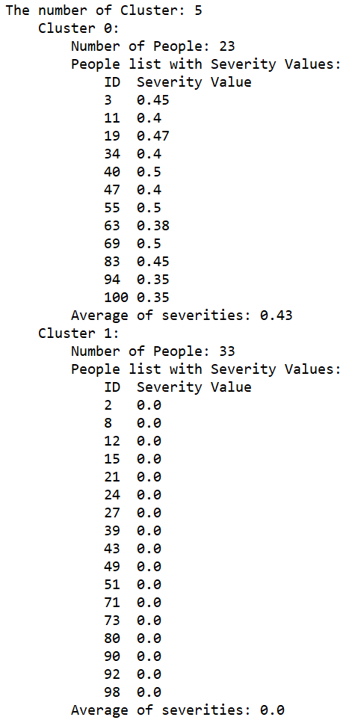

* Cluster 2, 3, 4

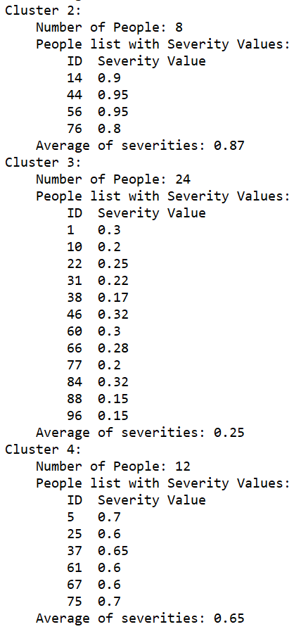

* The number of Cluster: 6
* Cluster 0

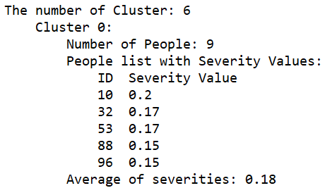

* Cluster 1, 2, 3

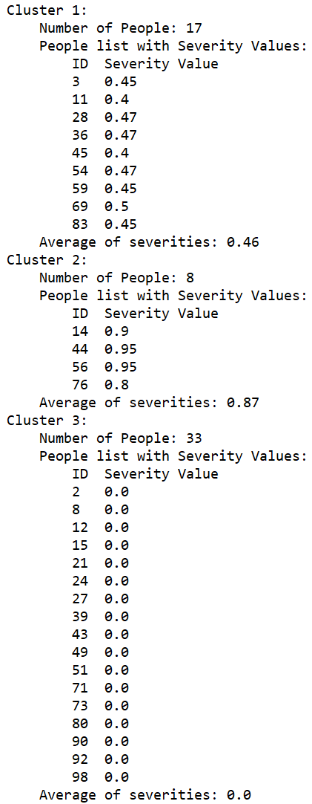

* Cluster 4, 5

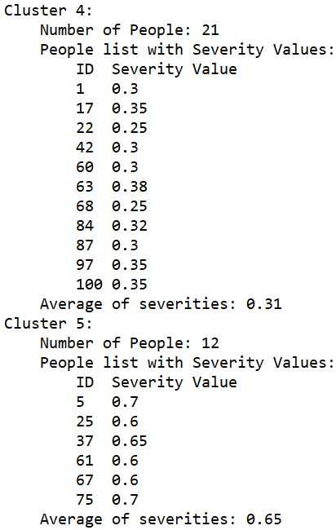

* The number of Cluster: 7
* Cluster 0, 1

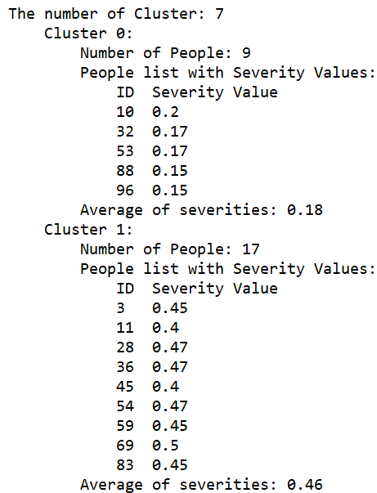

* Cluster 2, 3, 4

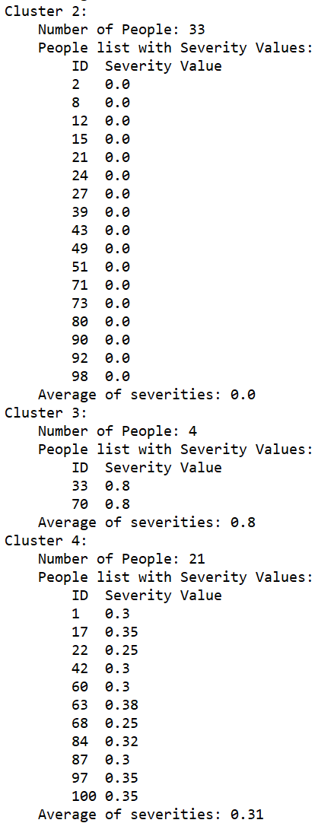

* Cluster 5, 6

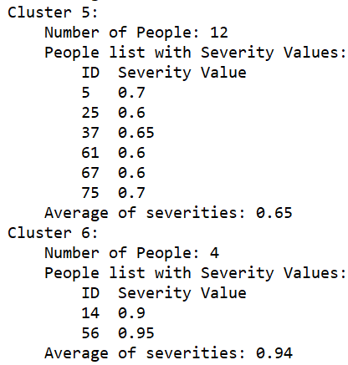

* The number of Cluster: 8
* Cluster 0, 1

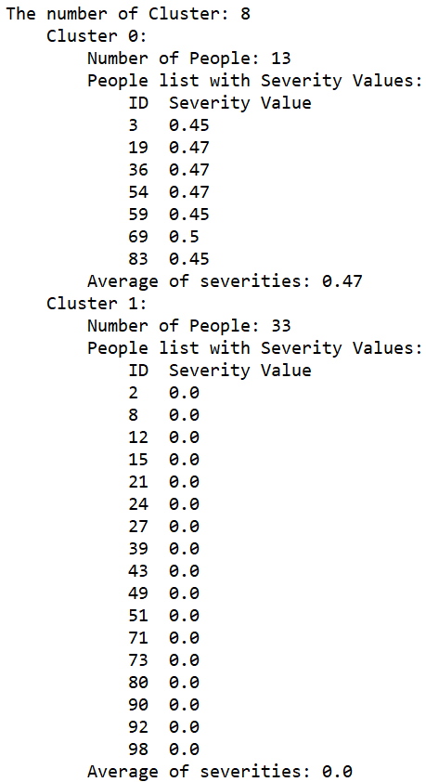

* Cluster 2, 3, 4, 5

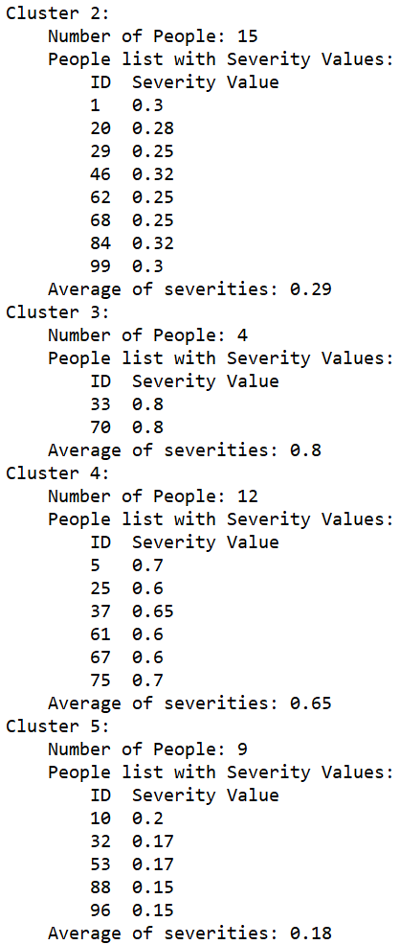

* Cluster 6, 7

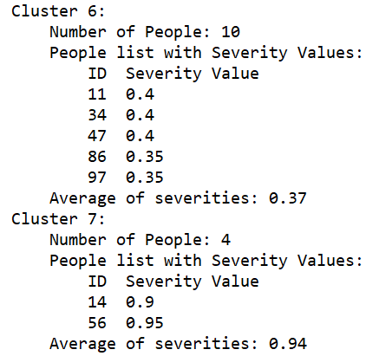

* The number of Cluster: 9
* Cluster 0, 1

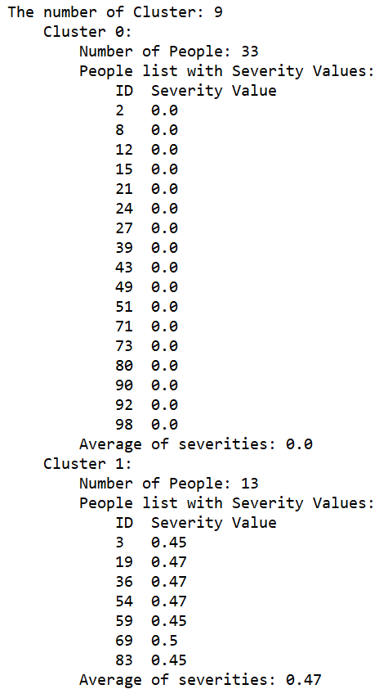

* Cluster 2, 3, 4

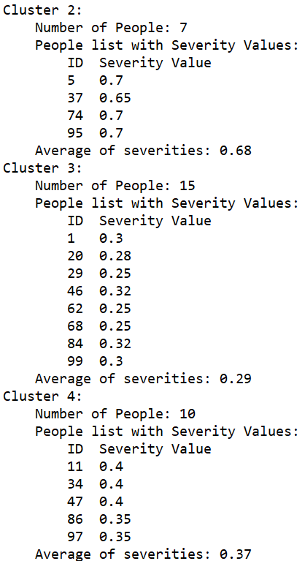

* Cluster 5, 6, 7, 8

